(SIEM) Security Information Event Manager

Blue Team

Home Lab

By Victor Patterson Sr

Cybersecurity Tools:

Cloud **Linode**,

**Linux** server, Flavor **Ubuntu**, **Wazuh**

**PowerShell, VM Oracle,**

System Requirements: 4GB RAM for the server

My first step is to download Linode & after setting up an acct. I came to a home screen like this.

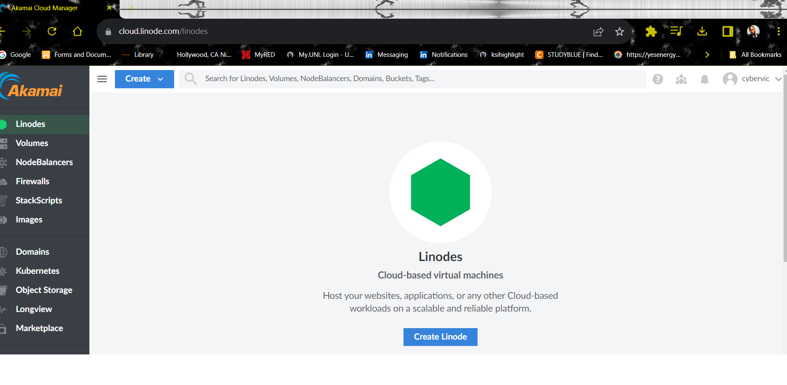

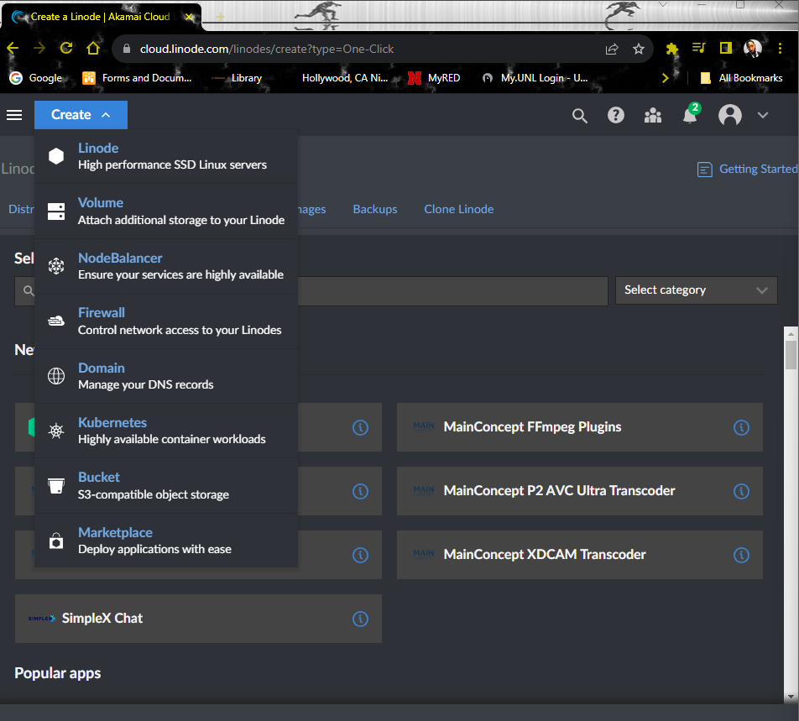

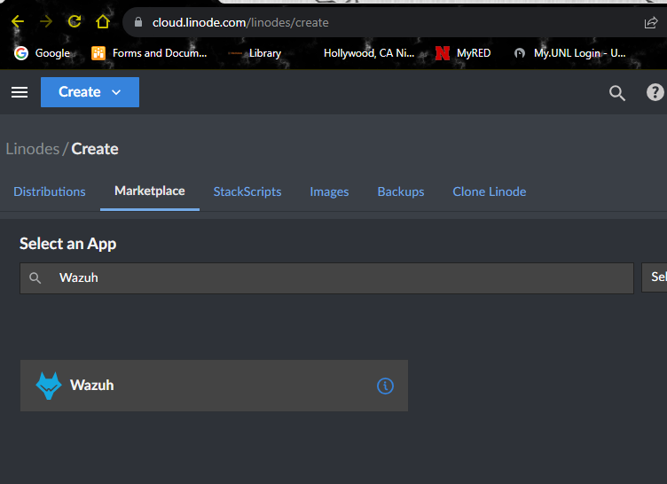

2nd step is to click the drop down button **create** >**Linode** by going to the screen: Next in the **Marketplace** I used the searched tool and typed **Wazuh** which is a type of Cybersecurity Tool that’s Open Source and (SIEM) Security Information and Event Management that blue team Defensive will use as well as I would.

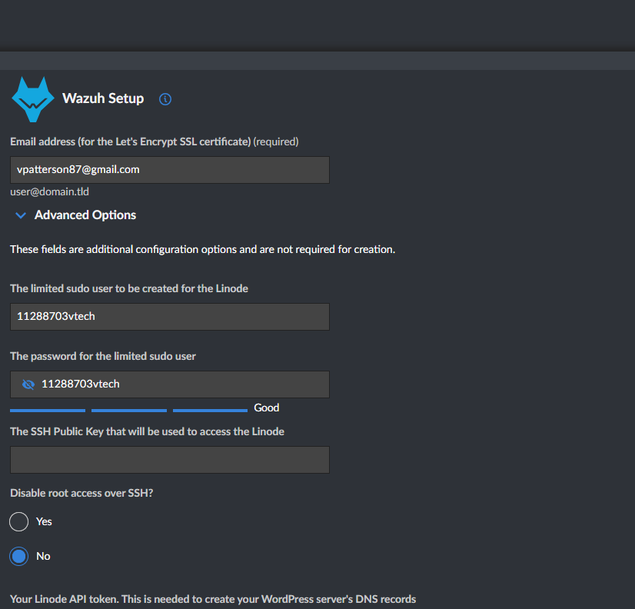

Next I create a domain and make up a sudo password of your choice. Then scrolling down I select an image were I will be using **Ubuntu** >select the closest **Region** and finally select my Linode plan. I choose Shared CPU because its cheaper and I will have plan or the size of the VM.

Next: I choose Linode 4GB which will provide a substantial amt of space.

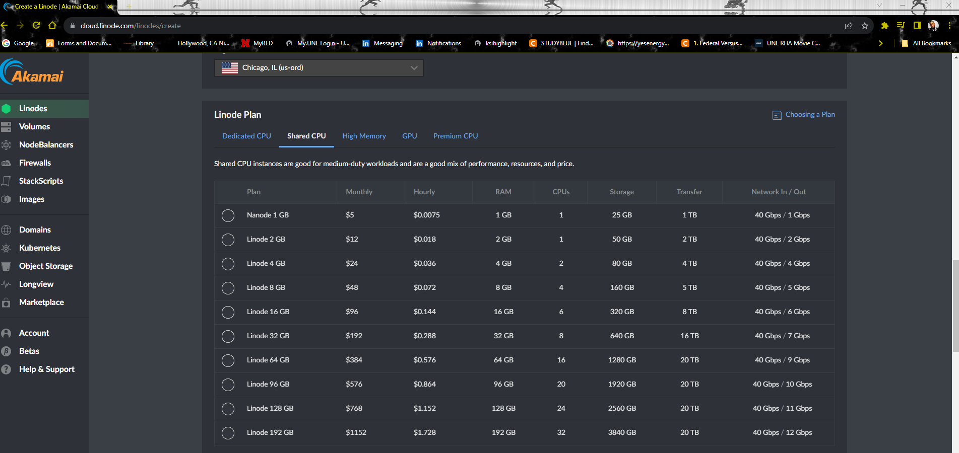

After choosing the amt of GB I created my label and root password for this lab's sake I kept it the same. Once This step is done simply scroll down and create Linode Machine.

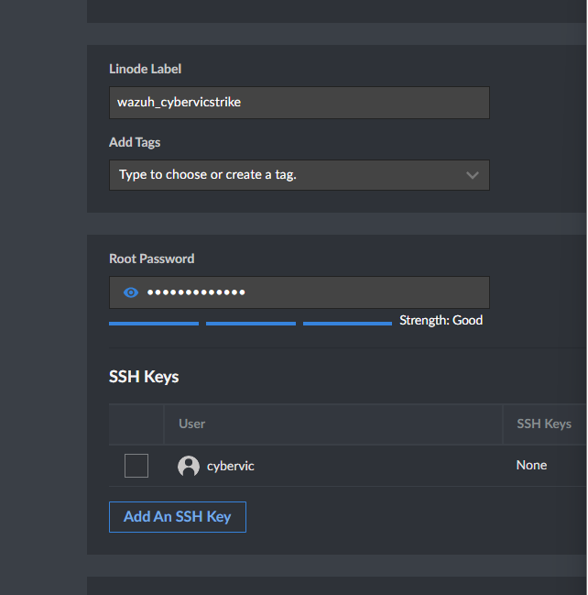

Create

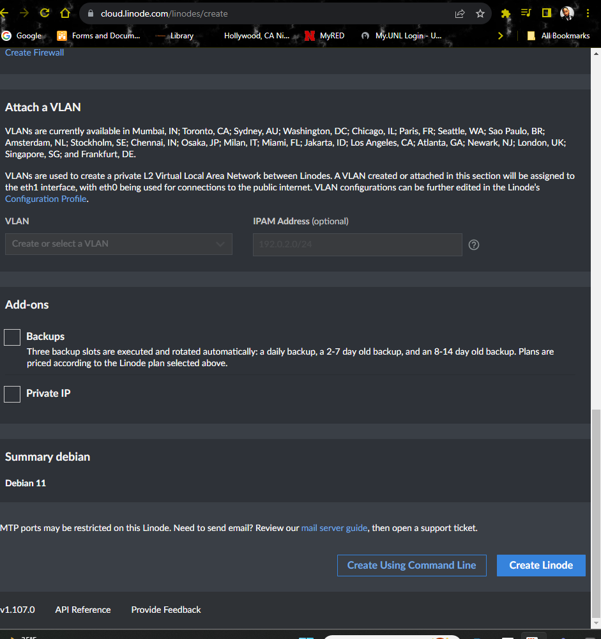

Once This is finished I have successfully created a VM in the Cloud as shown. I can see my SSH access Secure Shell for networking

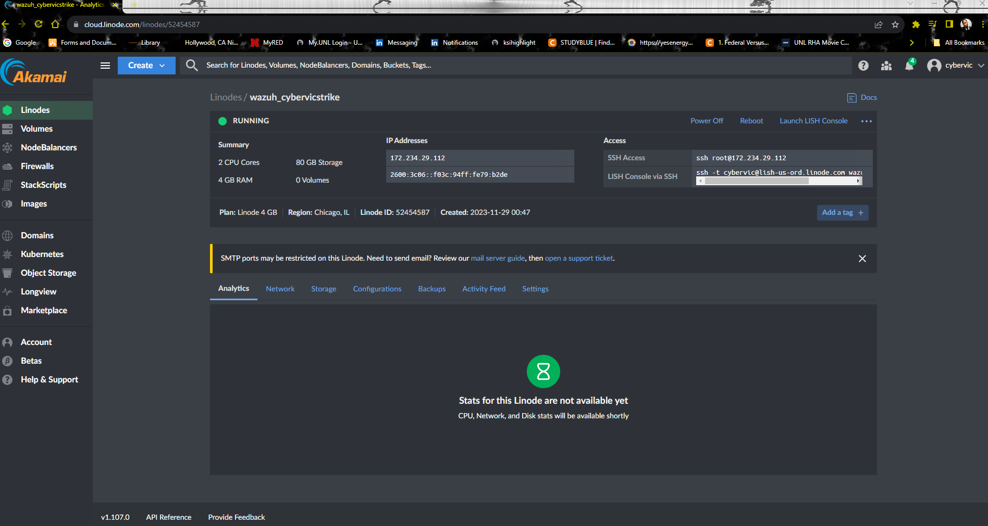

After creating my Cloud VM next I copied my SSH Access key: ssh root@172.234.29.112 and opened my terminal on my PC. ***Note***: Any terminal should work. I choose. Admin **PowerShell** from Win11 and past my SSH access key:

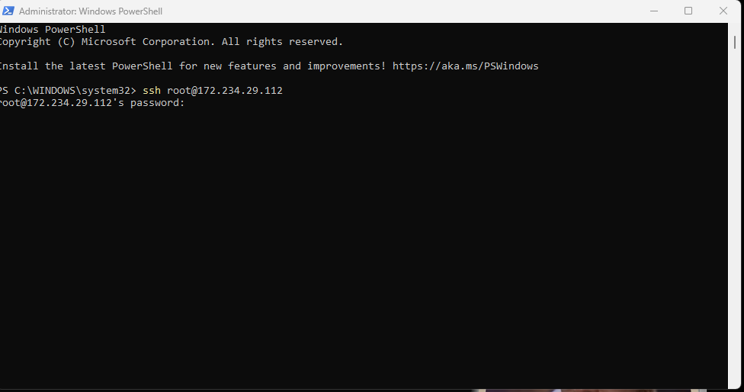

After typing my password created from earlier deploying my VM I now have access.

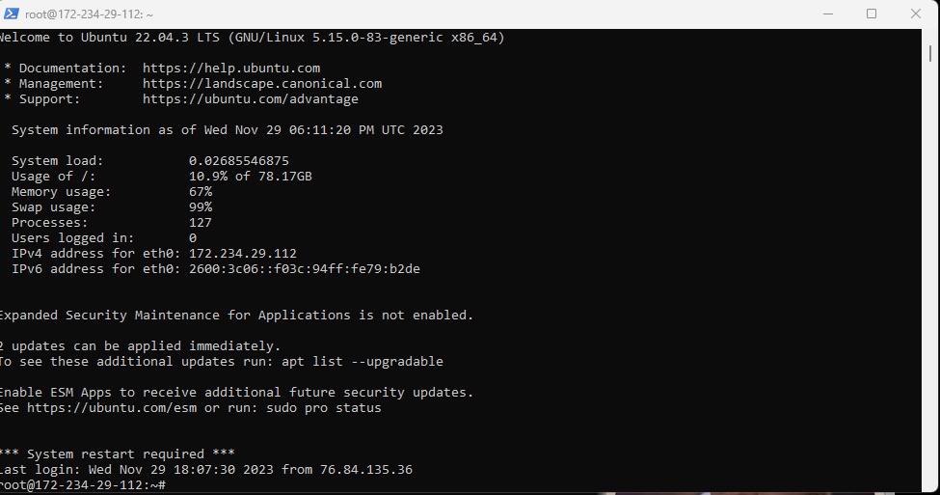

I can monitor by typing **htop –** which is an interacitive system monitor process viewer and a process manager.

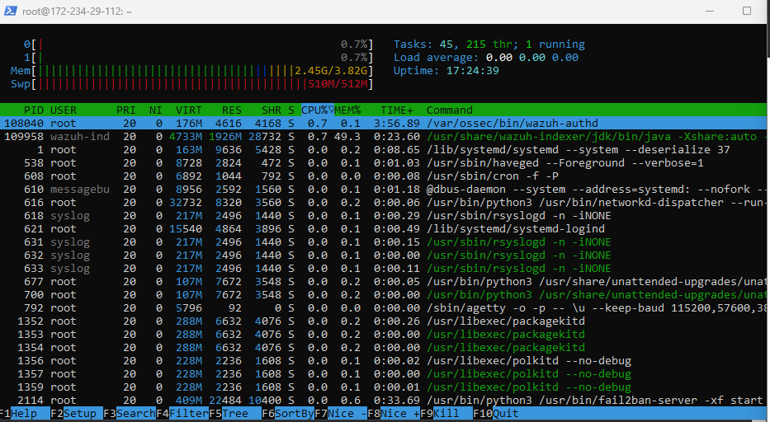

Once I was able to login successfully with my password I noticed that DPKG or called the D package in **Linux** which was installing

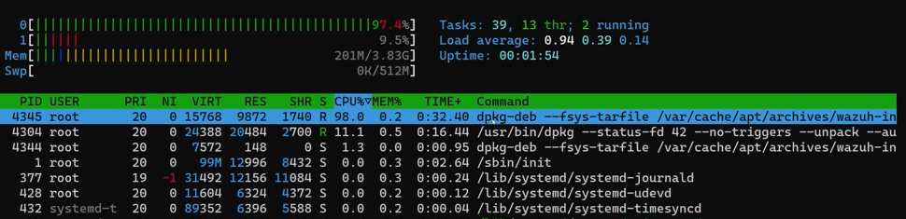

In order to exit Press Ctrl C to exit back to your main menu

Next I’m going to retrieve my password by typing ls -al back the terminal

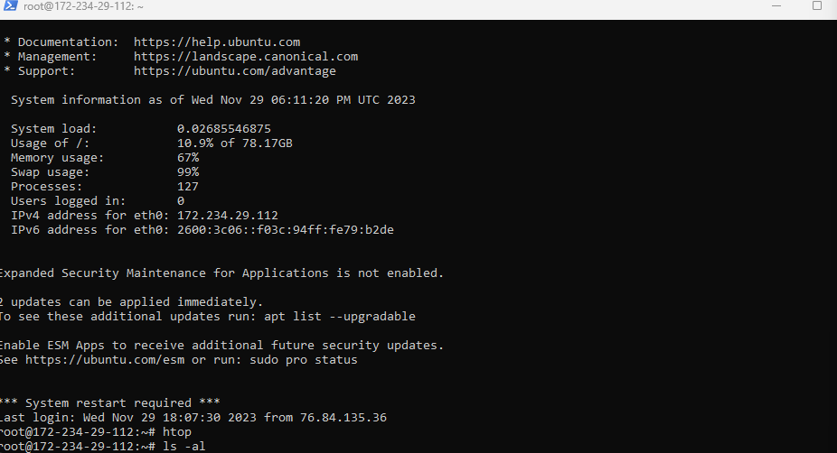

You should see (.deployment-secrets .txt file). There it has our secrets of my passwords

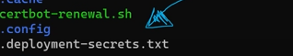

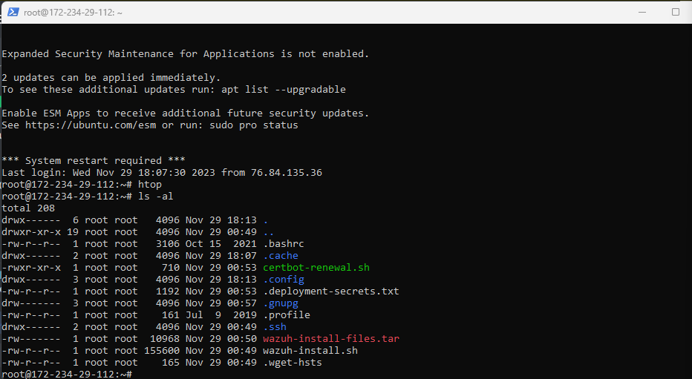

cat .deployment-secrets.txt

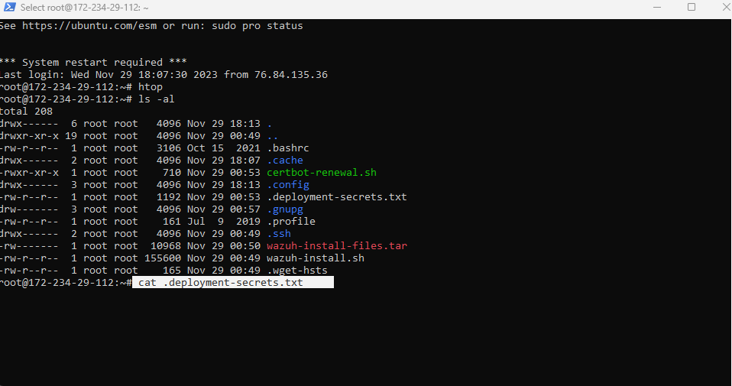

Once again successful I received a screen like this showing my passwords.

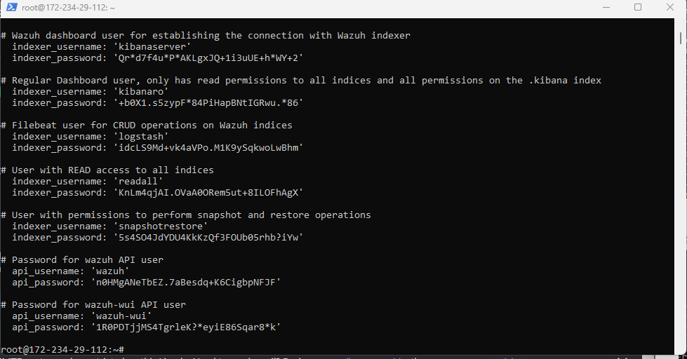

The password I’m seeking is the administrator password as shown.

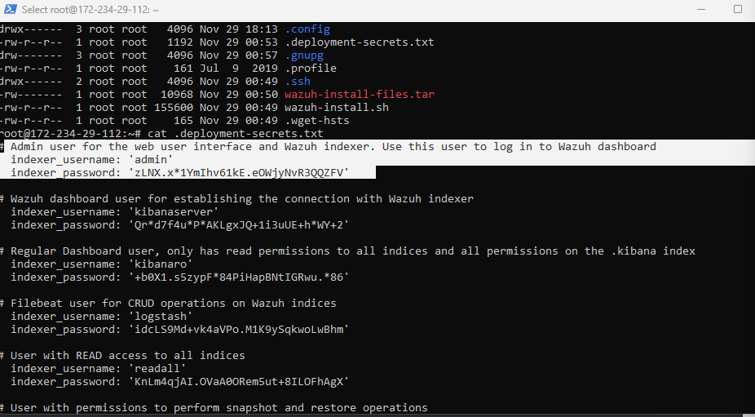

The next step is me going back to my Linode VM to obtain my LE node reverse DNS.

In order to locate this I click on my **Network tab**> scroll down to the ip addresses > copy reverse DNS

Reverse DNS 172-234-29-112.ip.linodeusercontent.com

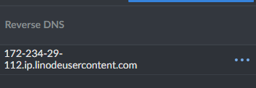

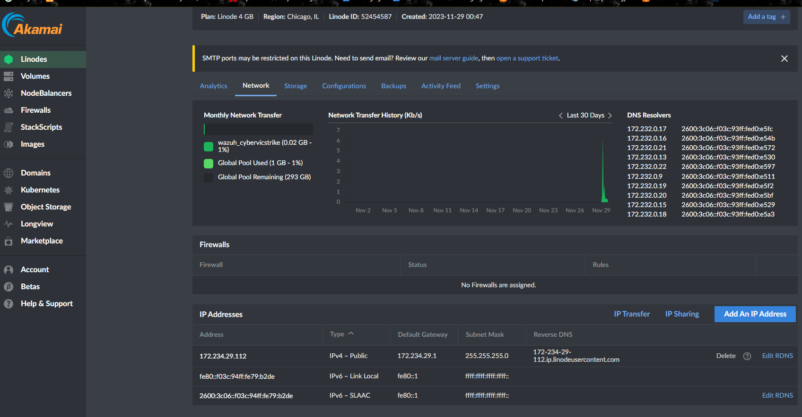

After this I Opened another Tab

Typed :https:// 172-234-29-112.ip.linodeusercontent.com

Since I was successful I got a page like this to login.

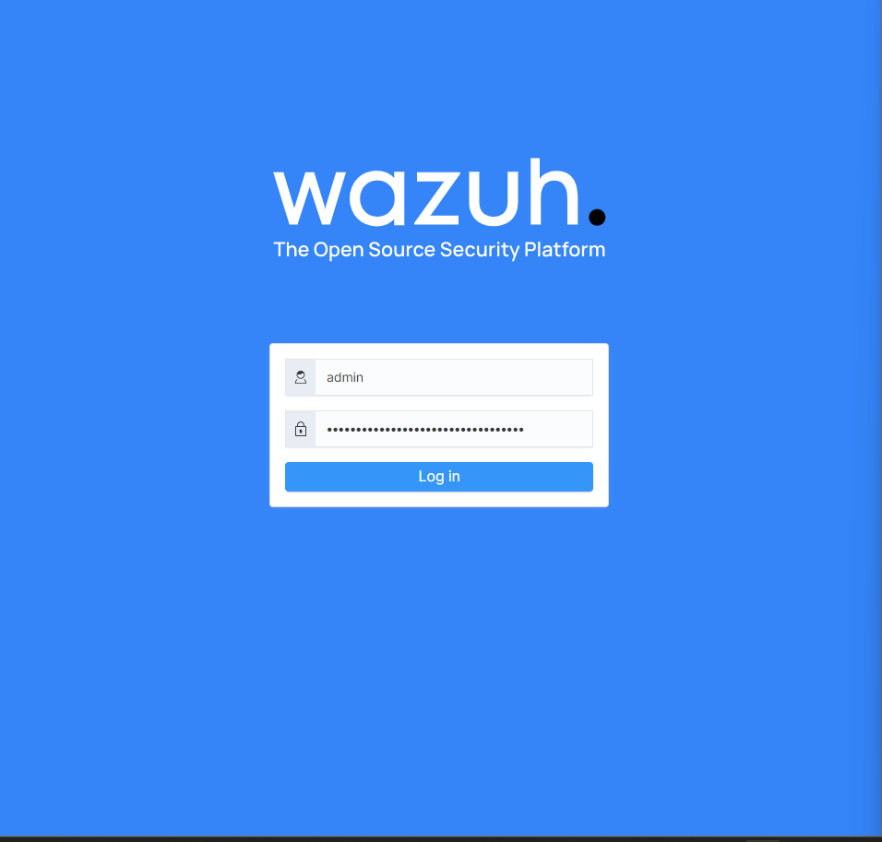

Now the user name is admin and the password will be from my terminal.



After this was done successfully, I now have access to add agents.

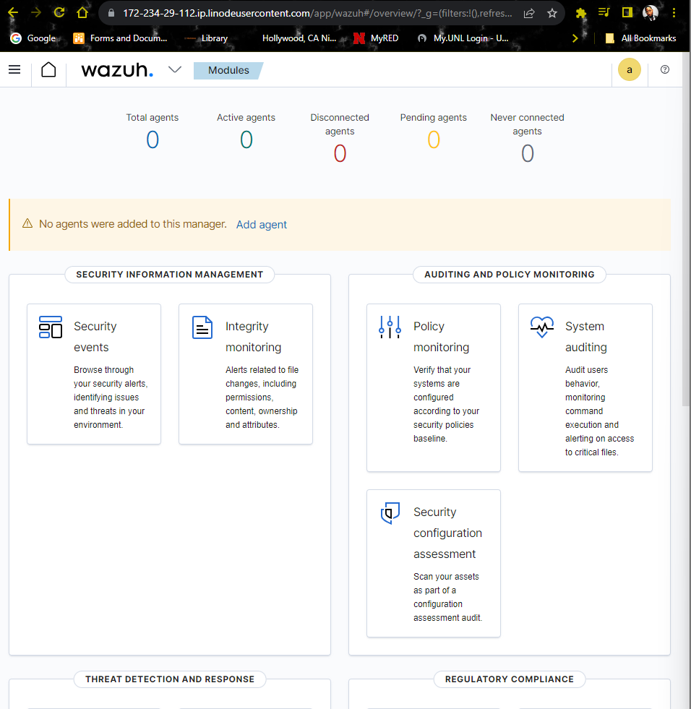

How to Install Docker

Create Linode > images Ubuntu 22.04 >Tab>Shared CPU> LE 2GB

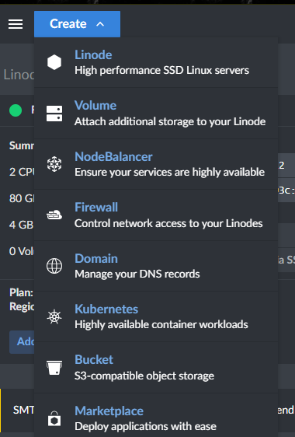  
Note; 2gb is confirmed to work on Docker

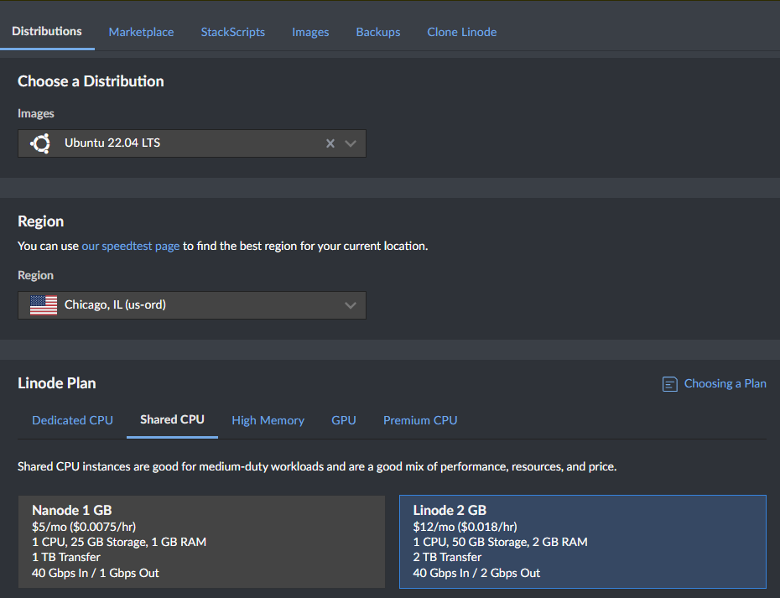

Created a container name for my Docker w/t Password and create the Docker.

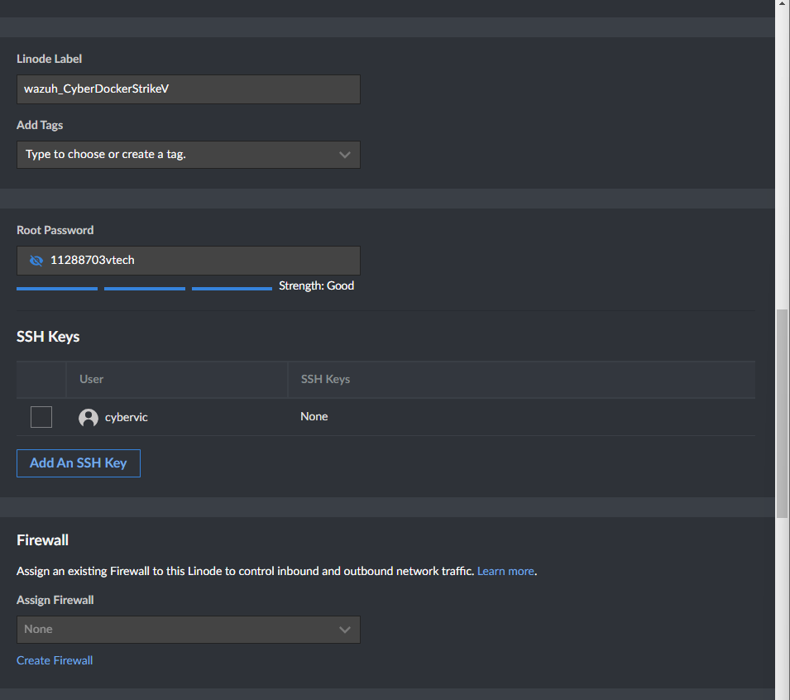

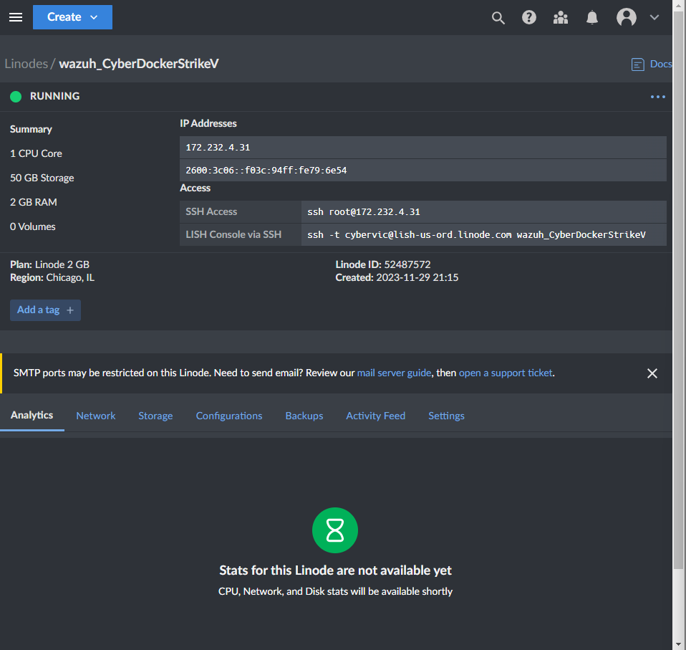

Copied my SSH Access key again and opened my terminal

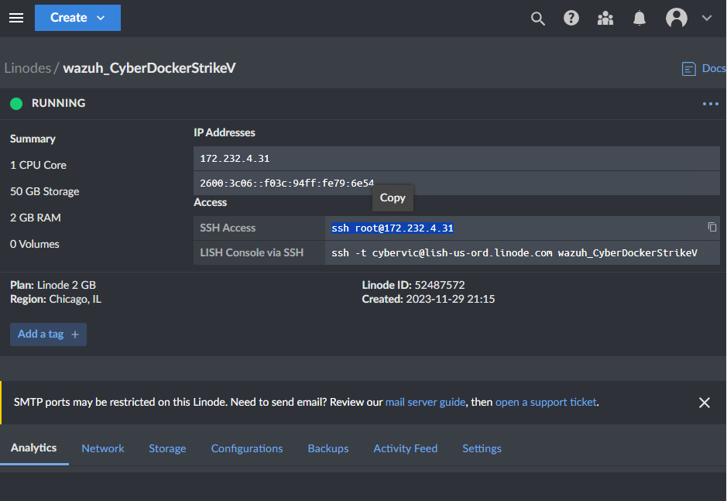

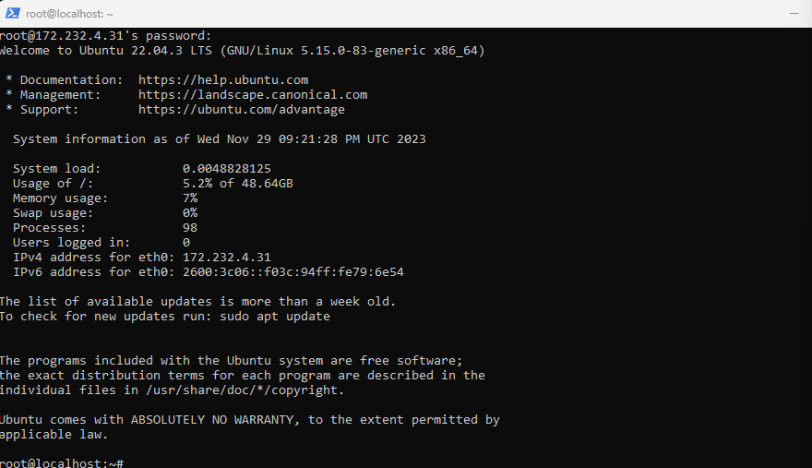

And I am in but I will update my repositories sudo apt update.

***Note***: recommened doing repositories updates b/c you may not be on “Root”

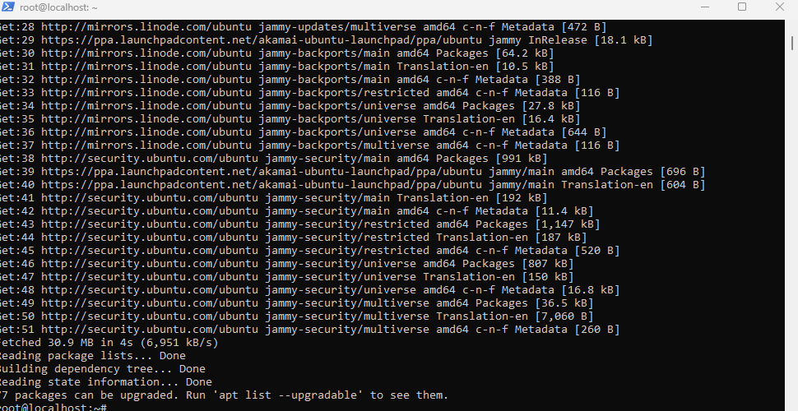

After this step, I typed sudo apt install docker.io docker-compose -y

This will install docker & docker compose.

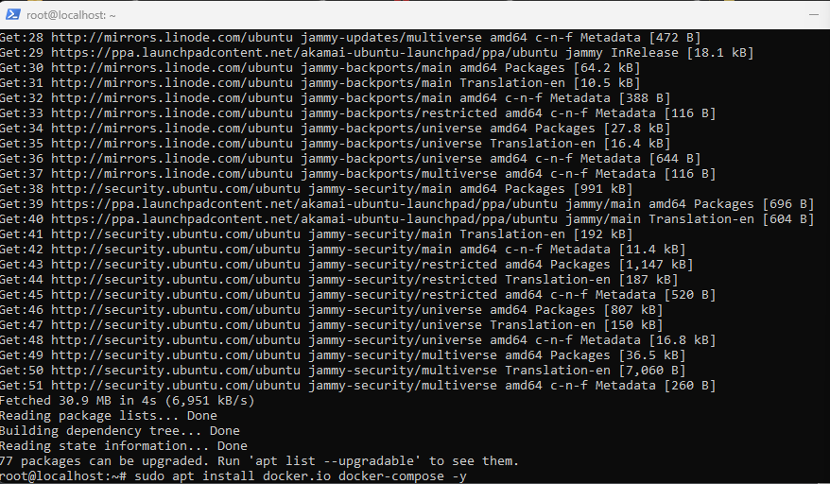

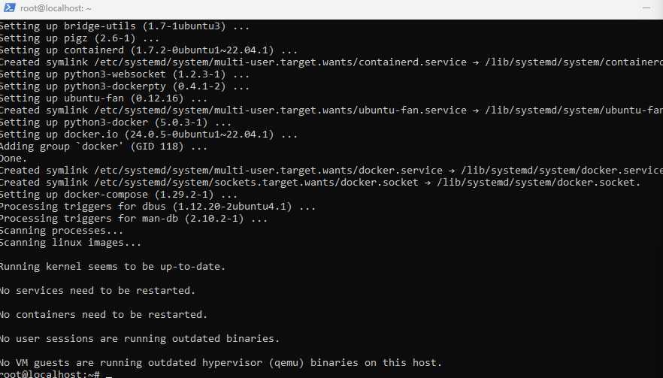

After this I use the Wazuh Doc. To copy the Git clone. <https://documentation.wazuh.com/current/deployment-options/docker/wazuh-container.html> to clone the the git repository in one command.

git clone [https://github.com/wazuh/wazuh-docker.git -b v4.7.0](https://github.com/wazuh/wazuh-docker.git%20-b%20v4.7.0)

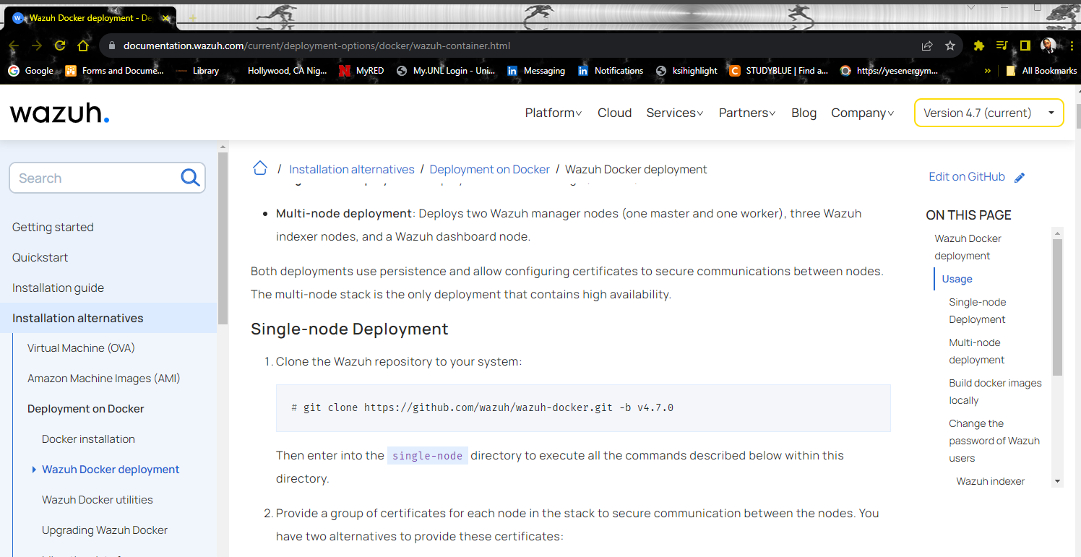

Note: You may have to type out Git code on the terminal once you do this It will be successful.

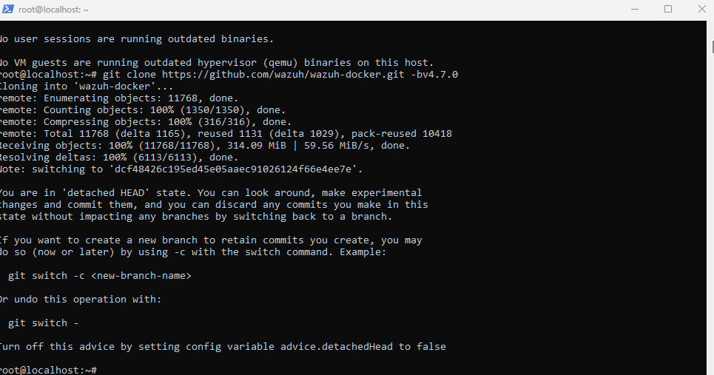

Next to confirm the Docker is created. Typed “**ls**” as seen Wazuh-docker is showing

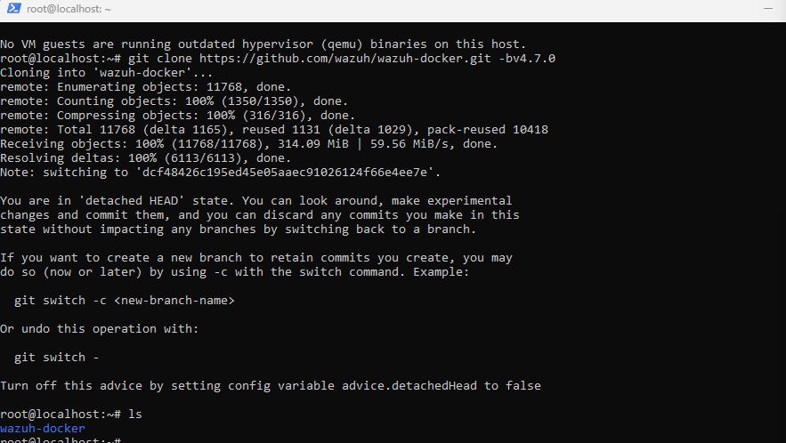

Next typing cd Wazuh-docker/

I enter the “Wazuh -docker# **ls** once more and I jumped into the directory because I am going to be deploying

One ***single-node*** or computer .

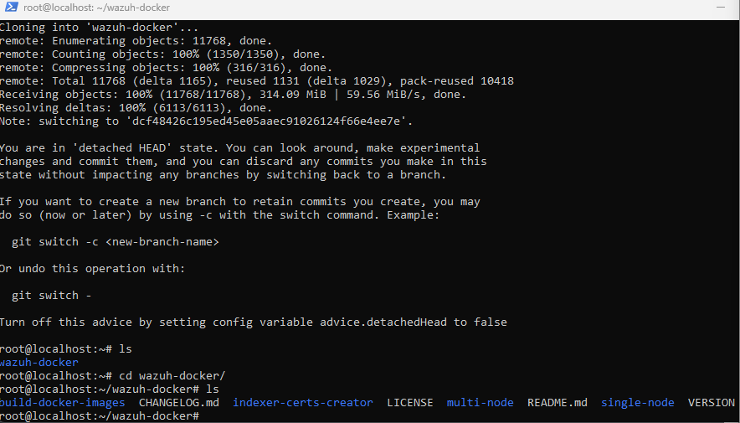

In order to do this I typed “cd single-node/”

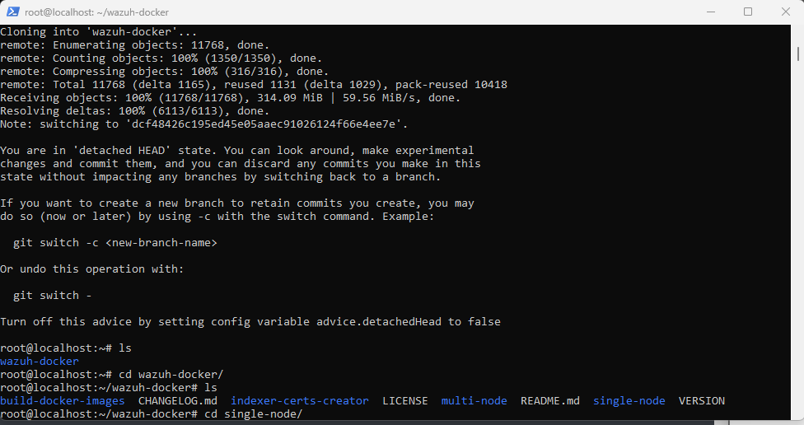

Before I do anything else I re-opened Wazuh document b/c I will have to generate some self assign certificates.

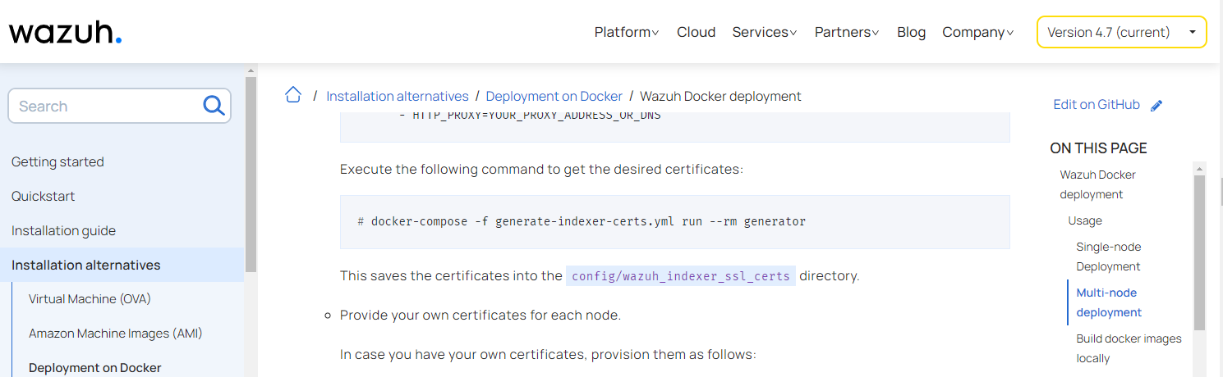

Copied: **docker-compose -f generate-indexer-certs.yml run --rm generator** and paste back in the same terminal I currently running.

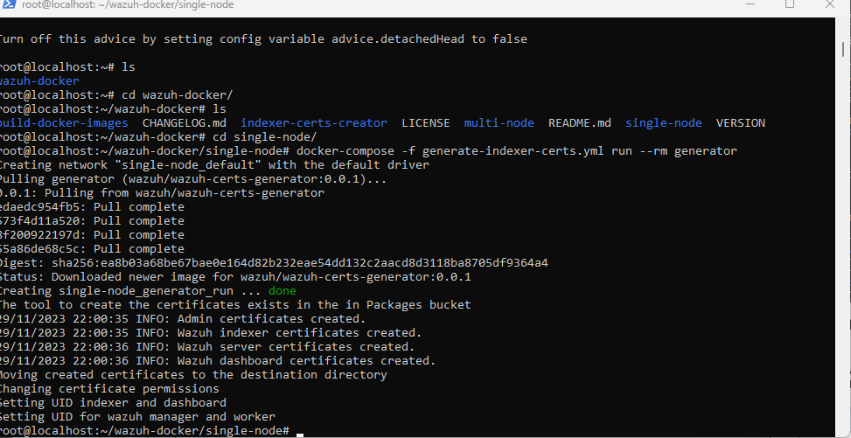

Next type docker-compose up -d command to launch it in the background. This will do everything for me.

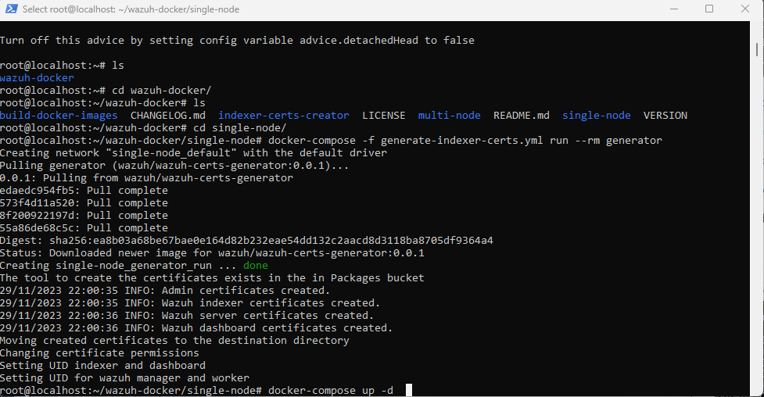

Since I am successful it is now deploying a multi-tier application, pulling all the images 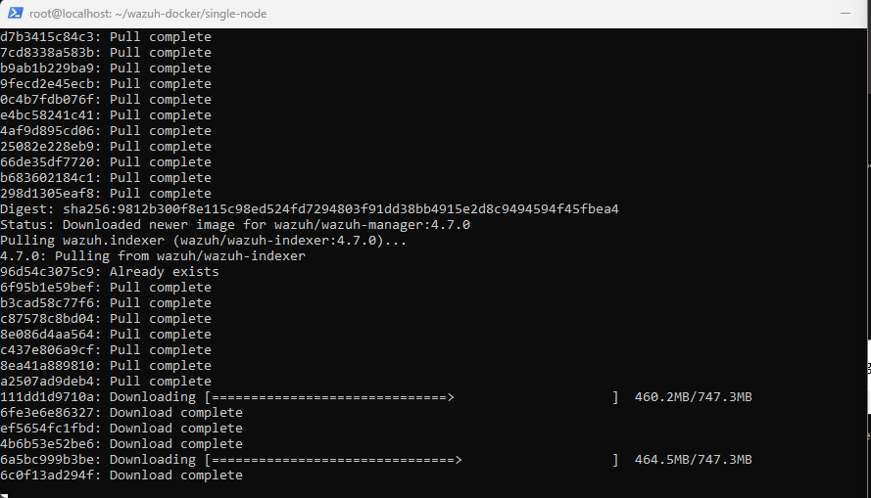

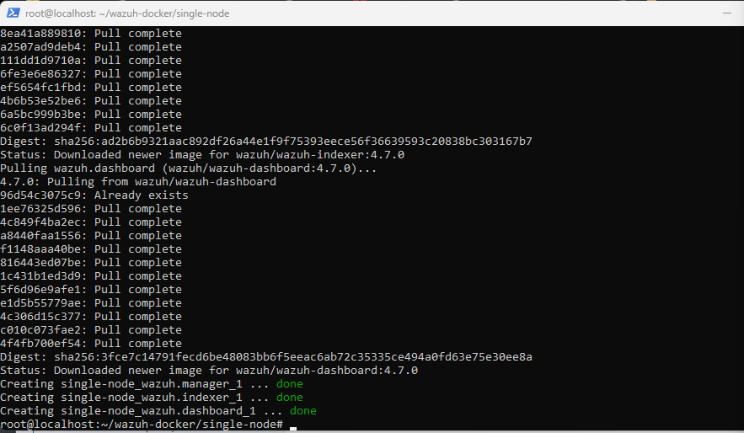

To confirm I typed “docker stats”

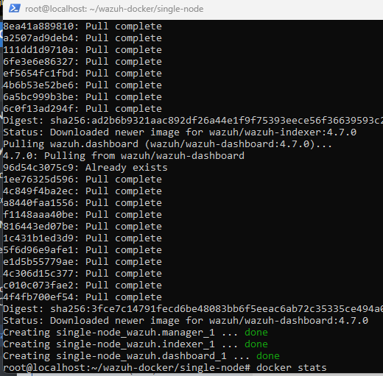

What this shows is realtime view of my containers.

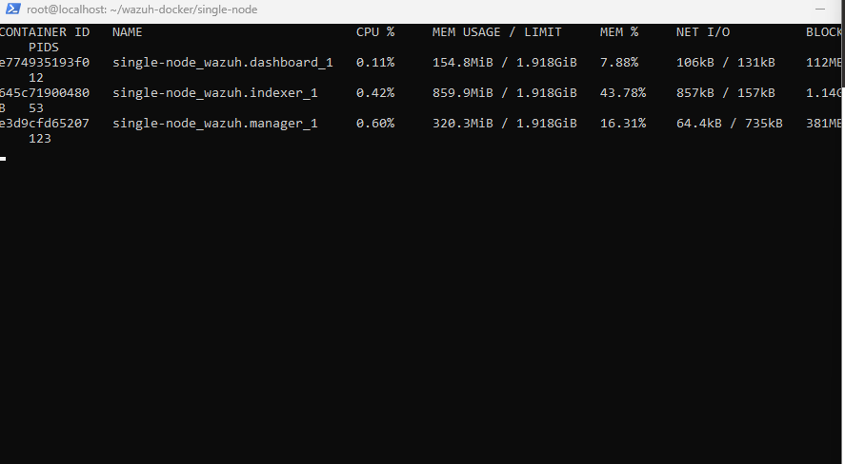

After verifying I went back to the LE to grab my reverse dns:

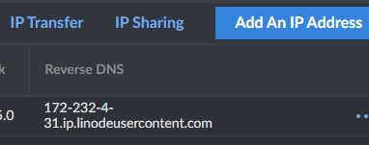

Same Process Log in with admin / Password this is case sensitive except the password this time will be located in Wazuh documentation..

User name: admin

*Password: **SecretPassword \***

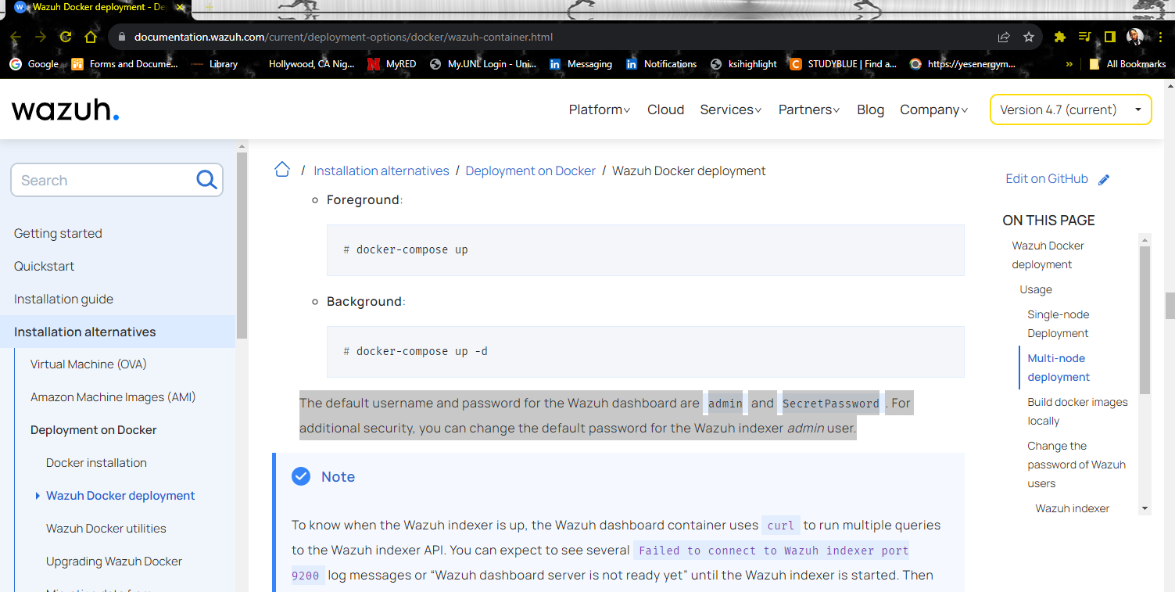

Now that This is completed, I will be adding agents.

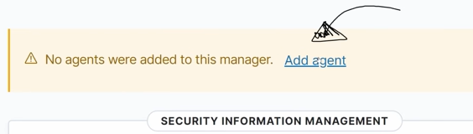

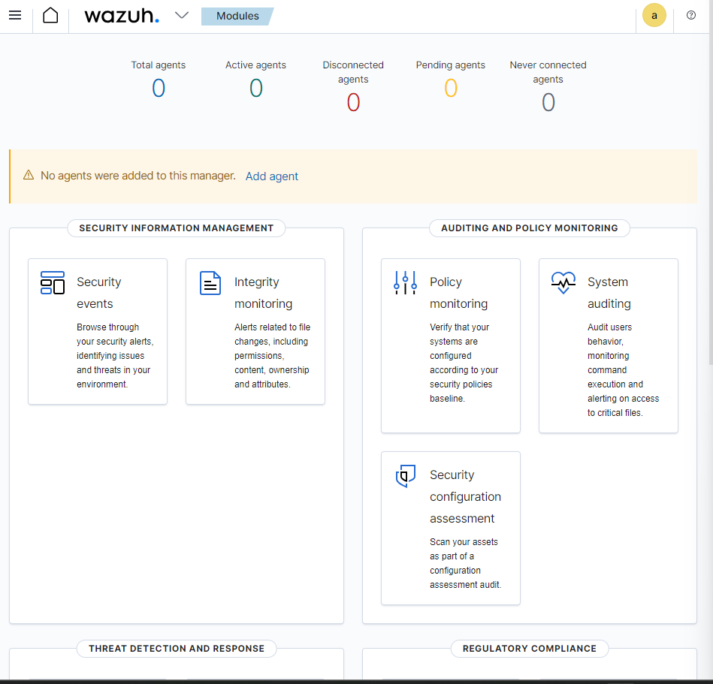

Next I’m going to Deploy a new agent.

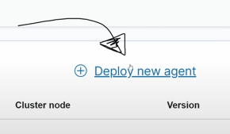

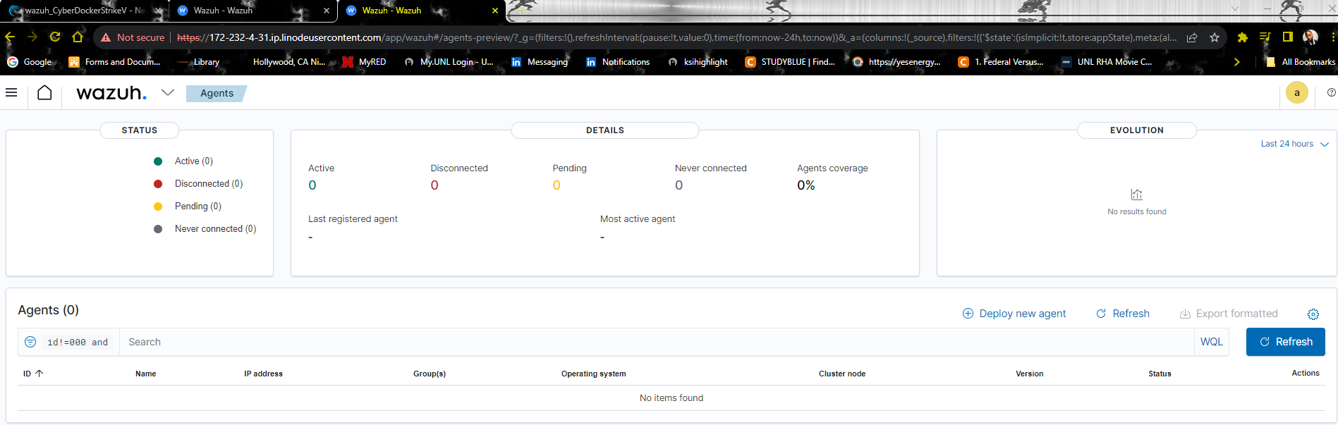

Next this process is straightforward but if new I have a awesome Video that helps with this entire process

Also I needed to be sure to assign a server address

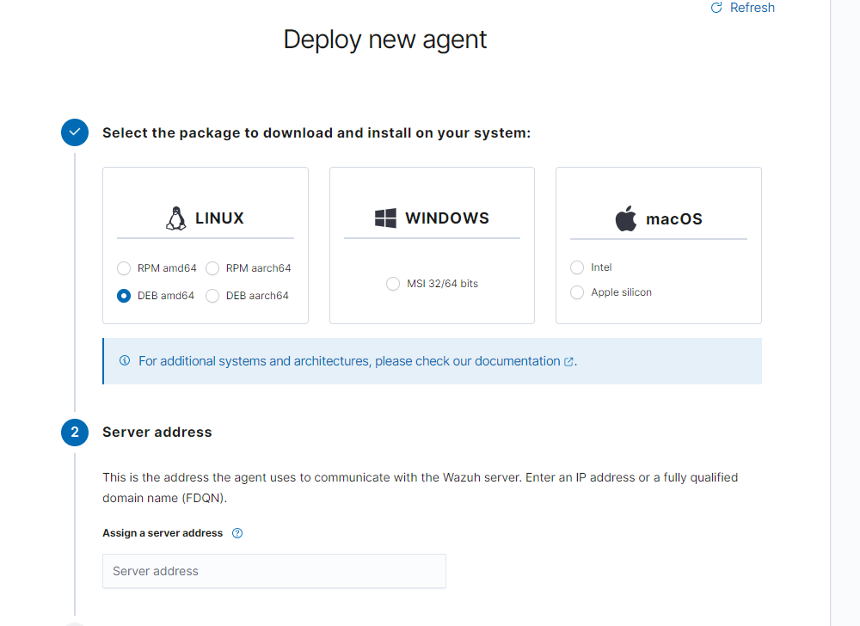

**Note**: The address would be the one **reverse dns** that you used.

Copy & paste that into the FQDN because it can be something that the agent can have access to.

172-232-4-31.ip.linodeusercontent.com



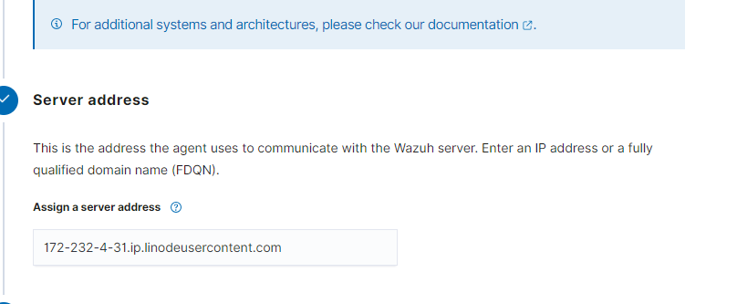

Next is to assign an Agent name.

I choose kali_linux

**Note**: You can make up anything you want.

After this I selected a group which is (default) so far your layout should look like this

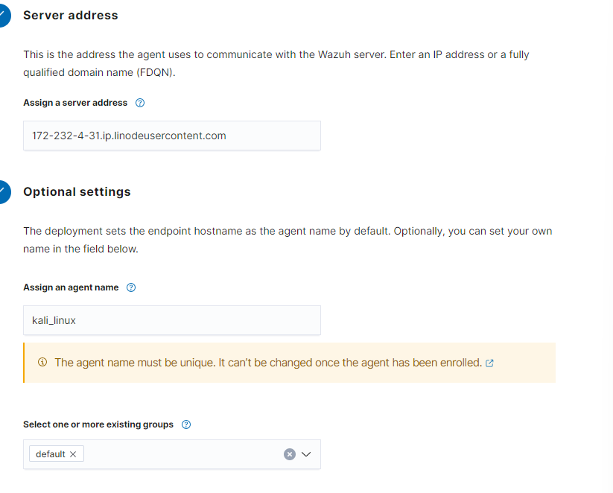

After this process I received the following command to install Wazuh agent: copy this command to

wget https://packages.wazuh.com/4.x/apt/pool/main/w/wazuh-agent/wazuh-agent_4.7.0-1_amd64.deb && sudo WAZUH_MANAGER='172-232-4-31.ip.linodeusercontent.com' WAZUH_AGENT_GROUP='default' WAZUH_AGENT_NAME='kali_linux' dpkg -i ./wazuh-agent_4.7.0-1_amd64.deb

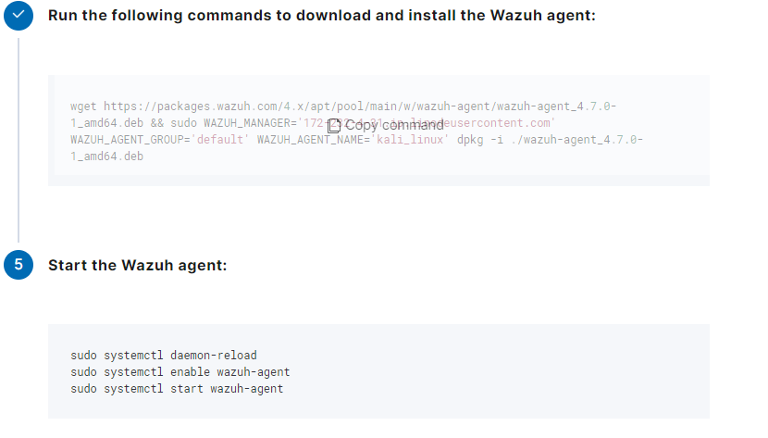

NOTE: You will need Kali Linux:

In order to paste your Command

Shift In the Kali Linux terminal, use **Shift** + **Insert** to paste the text.

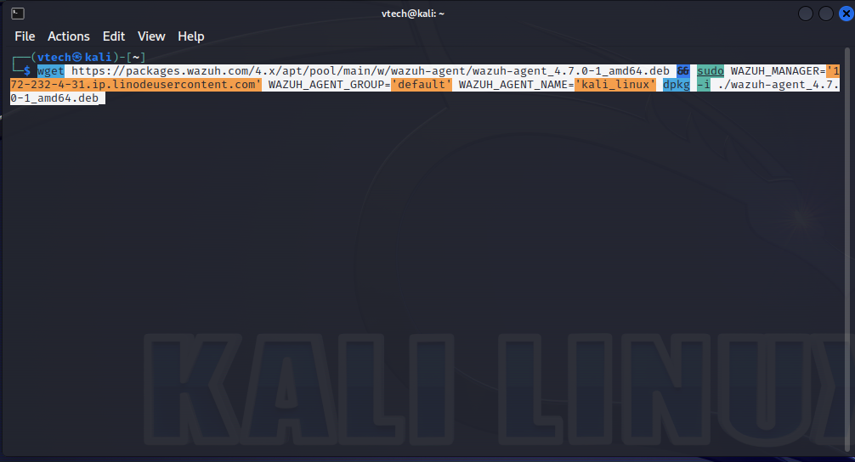

Once this is completed their will be one more part to this process back to the Wazuh dashboard

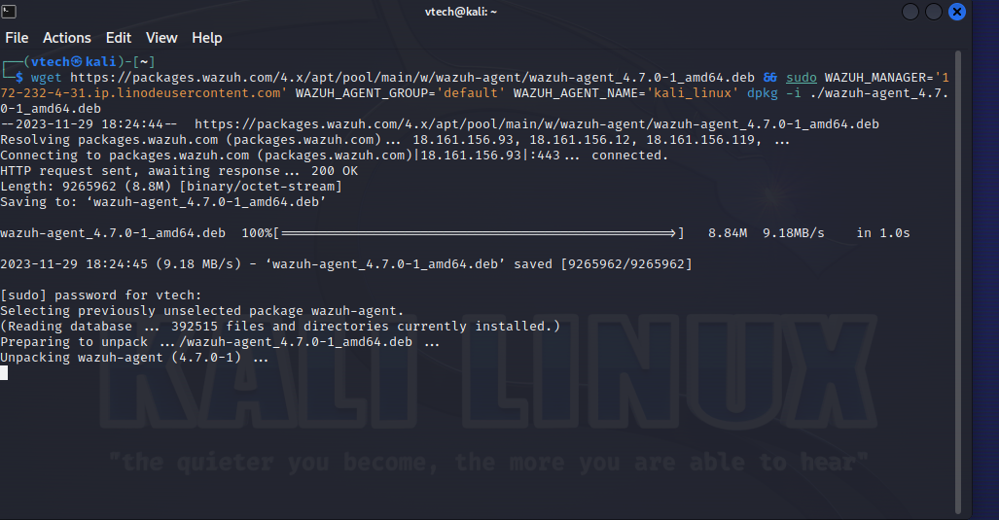

On dashboard I copied the Command for the Wazuh Agent:

sudo systemctl daemon-reload

sudo systemctl enable wazuh-agent

sudo systemctl start wazuh-agent

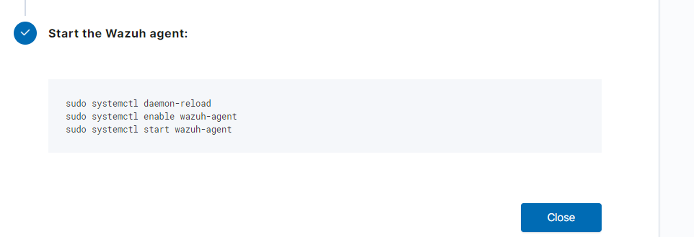

Paste into my Kali Linux terminal

sudo systemctl daemon-reload

sudo systemctl enable wazuh-agent

Nothing special input the command and done.

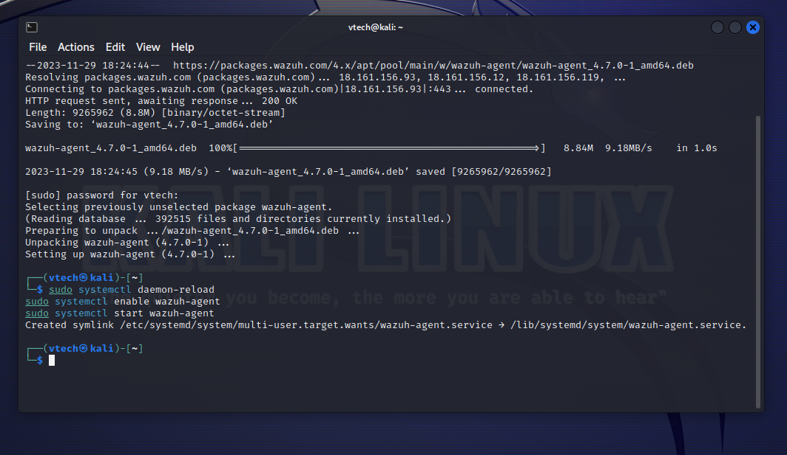

Once this is completed, I now have my to Agent -Kali Linux Machine is showing from my VM. Next will be Windows by **deploying a New Agent**.

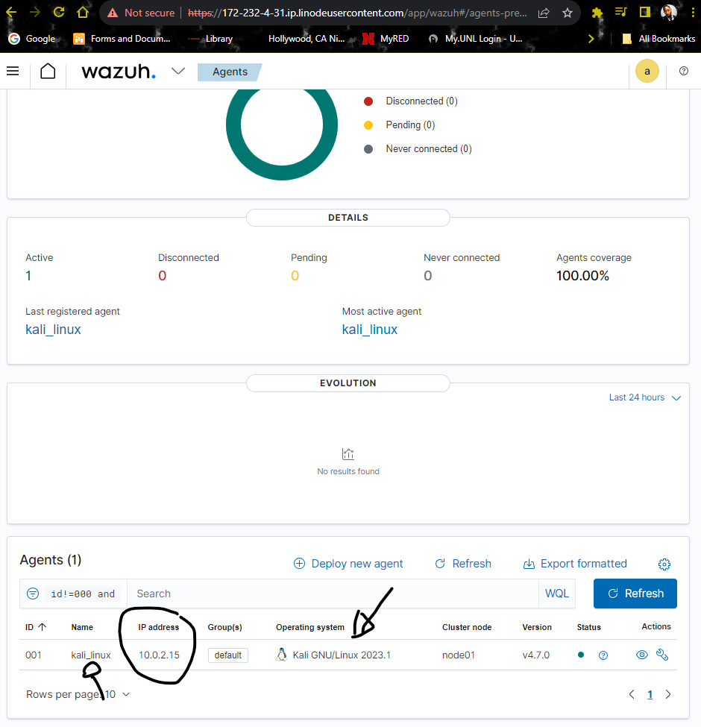

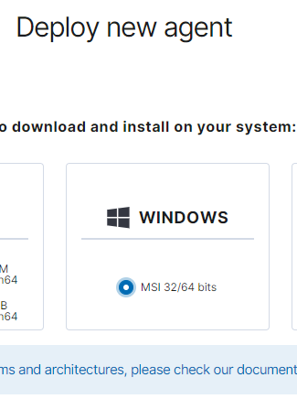

Next copy the ip address **172-232-4-31.ip.linodeusercontent.com** and **assign to the server address**

**Open PowerShell from PC. >copy the command to install Wazuh agent.**

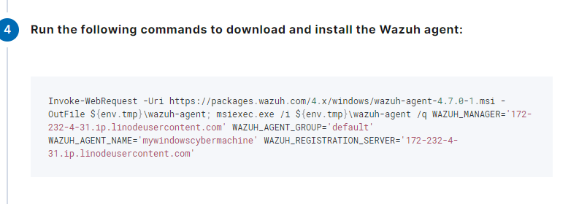

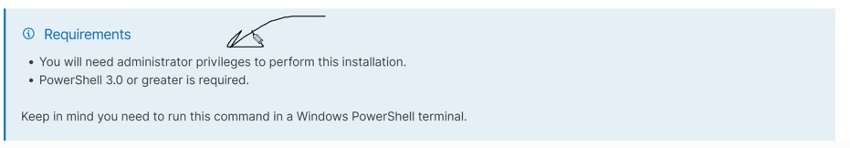  
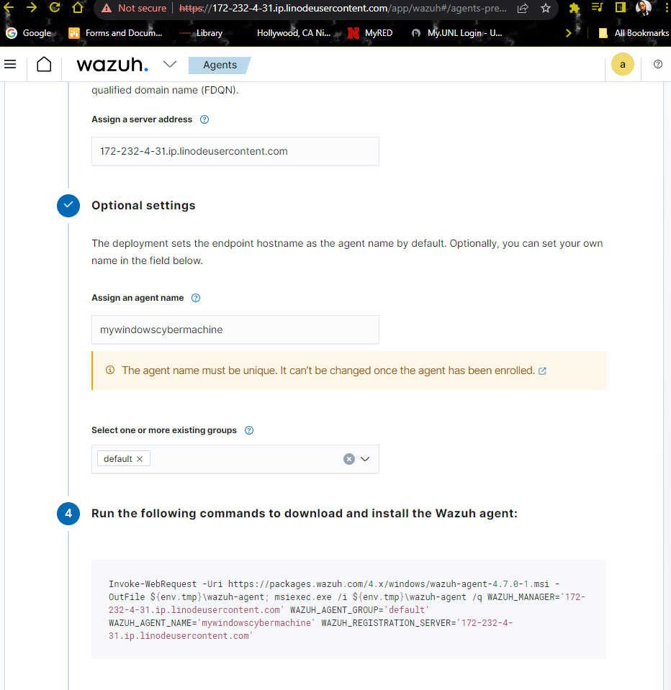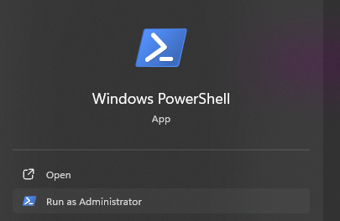

Important: run the command for the agent 1st then once it shows completed type “NET START WazuhSvc”. This is just like Linux net start was a svc

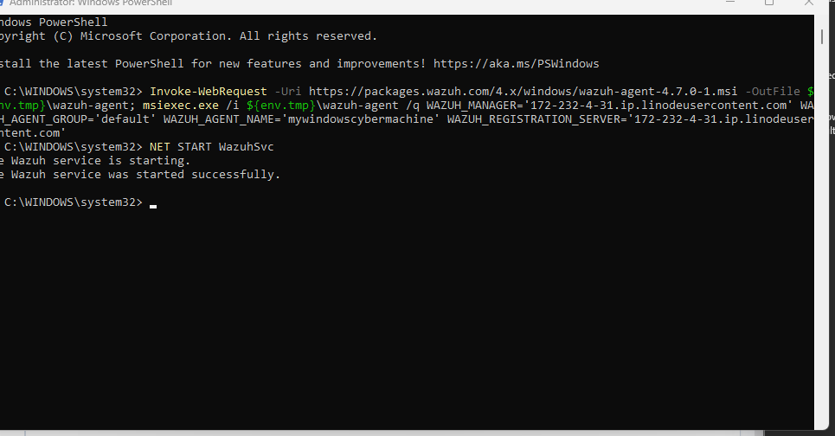

Next I went back to my Wazuh dashboard

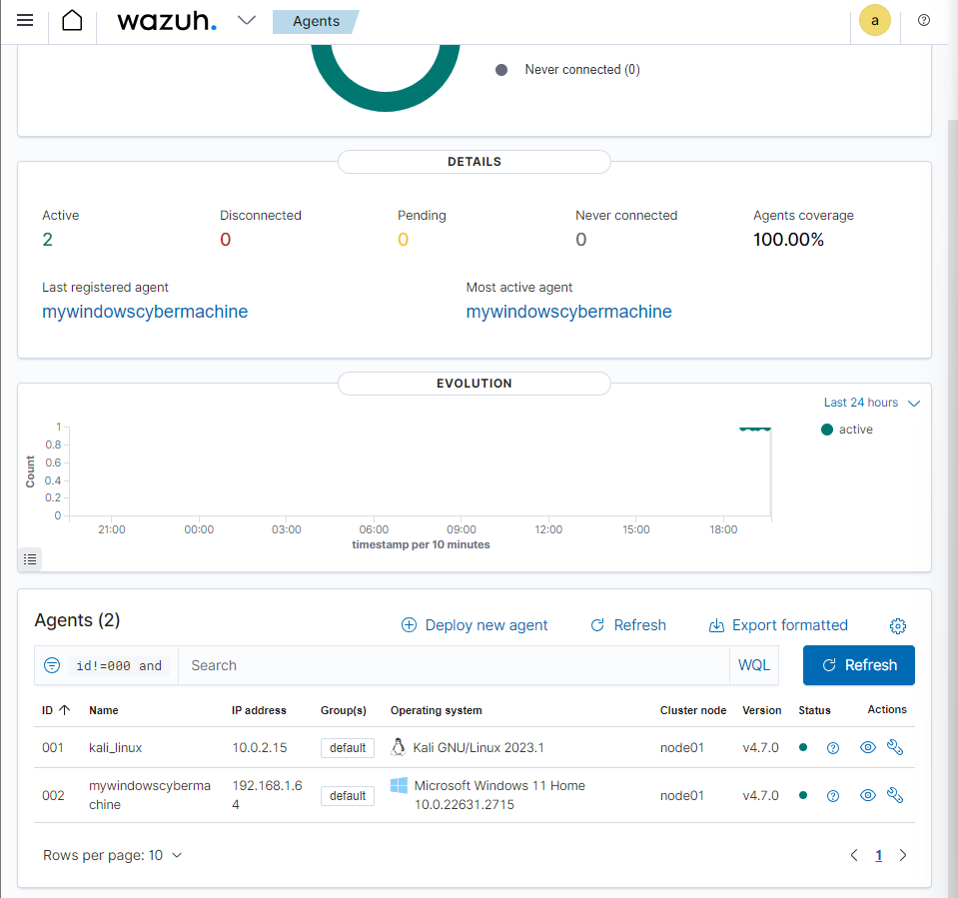

I now went from 2 agents to 4 agents

**Notes**!!: If you are to deploy Ubuntu: follow the exact same path EXCEPT copy and paste. The best way to install DPKG and updates are to follow these directions per the link.

<https://www.linuxtechi.com/install-virtualbox-guest-additions-on-ubuntu/>

**Note**!!: if you are to deploy Kali Purple Linux copy and paste updated will be needed follow these directions and also do not to try paste Ctl+V as this will right click and copy and paste

<https://www.kali.org/docs/virtualization/install-virtualbox-guest-additions/>

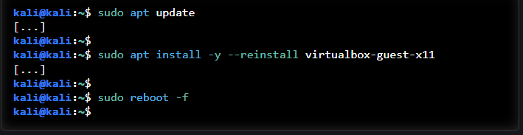

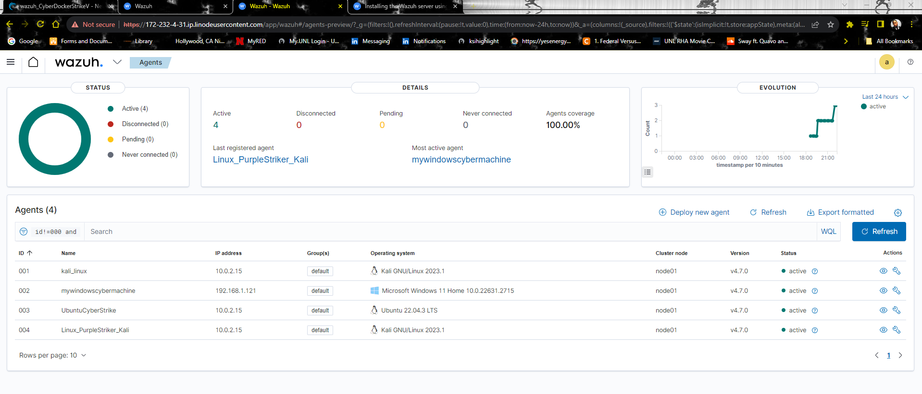

So now that I have my 4 agents my next will be to check my SCA *secure configuration assessment* by clicking on the eye to direct me to the SCA



This screen is an outline of my entire screen showing MITRE , Drop down option for Compliance , NIST, GDPR, HIPPA, etc.

The SCA will pull out an CIS assessment

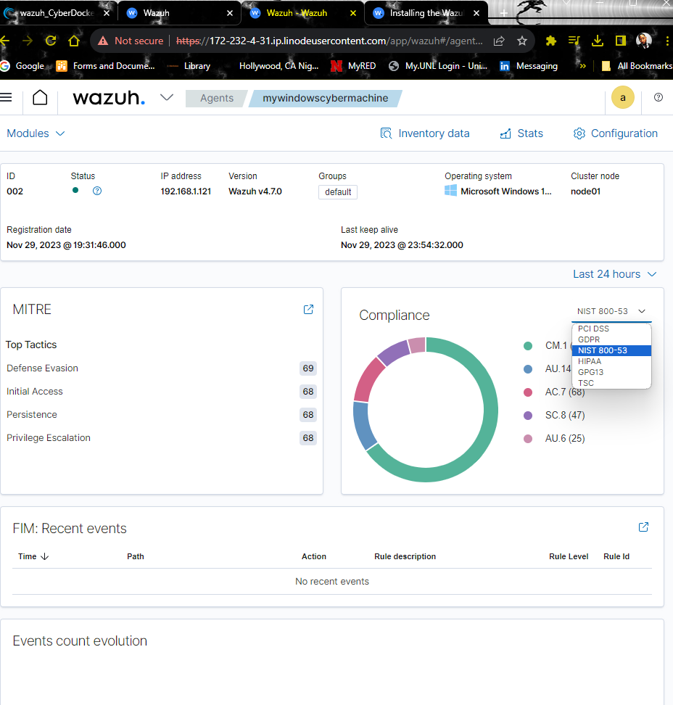

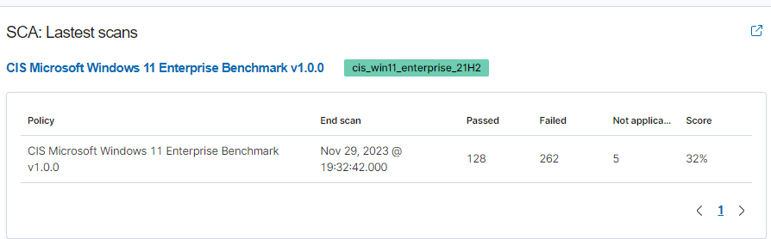

As you noticed I scored a 32% failed 262 to elaborate

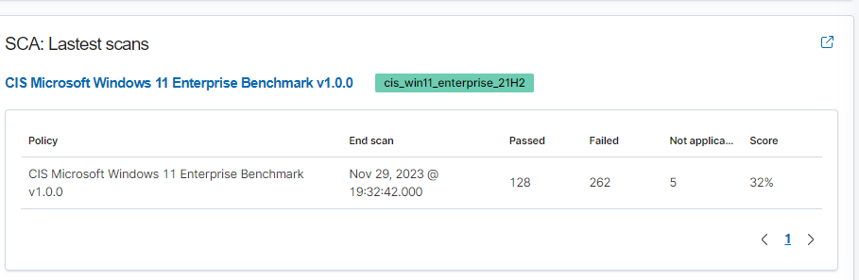

Opening my SCA allows me to see exactly what passed/failed and how to fix

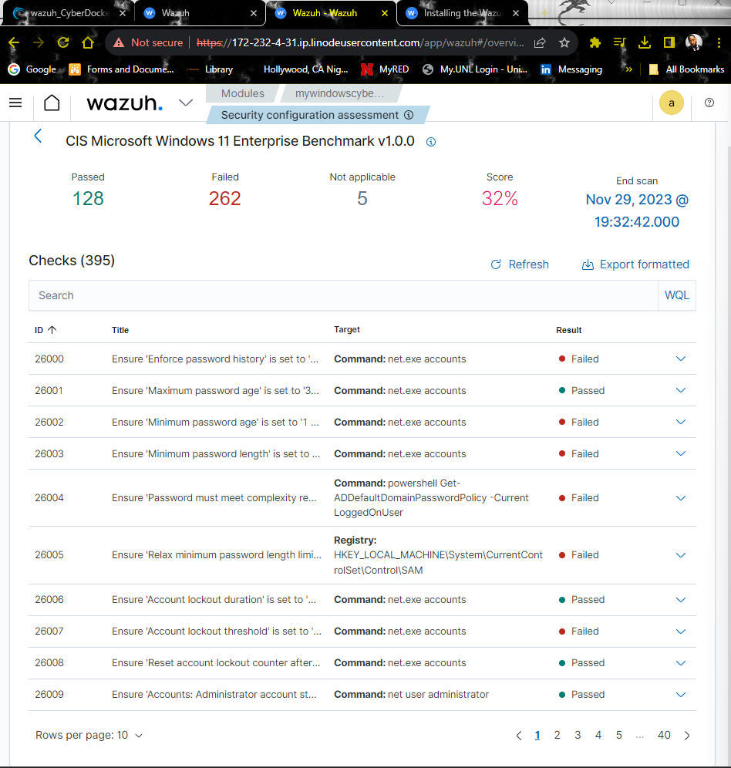

So for example I will go deeper by showing things like an disable USB storage.



If that drill down to SSH b/c I can search for specific things like that. So not only is it showing me it tells me whats insecure and teaching me **security**.

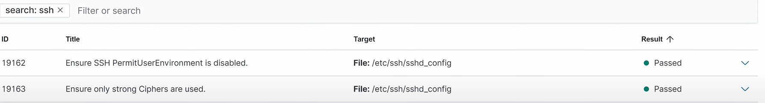

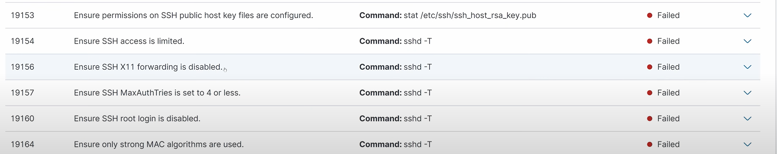

Example by clicking on result this will give an explanation of how to check it and fix it with the Rationale and so much more. As shown this also gives **MITRE techniques.**

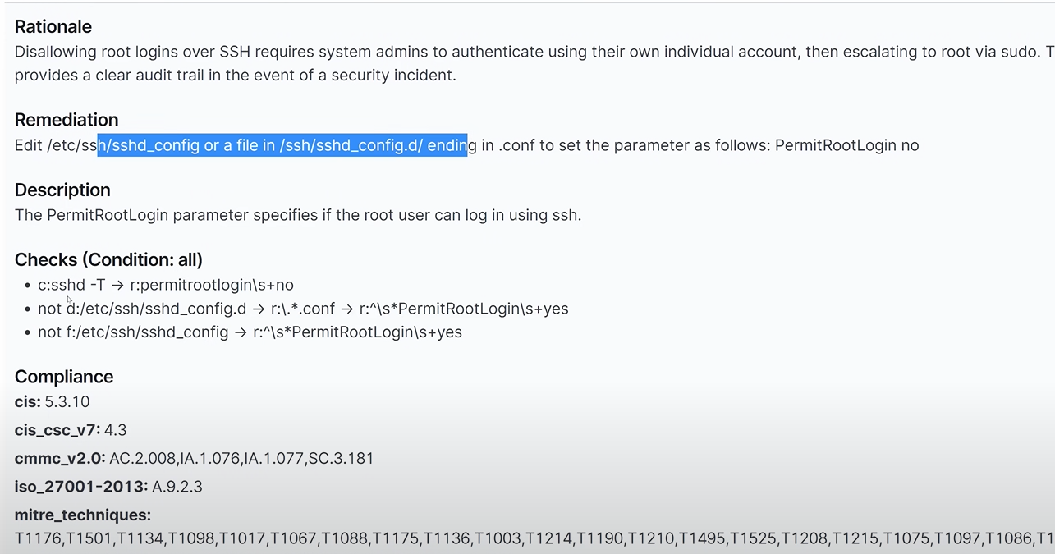

Main Dashboard has All Security Events. Clicking on Security Events leads me to see if I had “Authentication failures” which could be **“BRUTE FORCE ATTACKS**” I don’t have at this time to confirm. It will also show me my top five alerts.

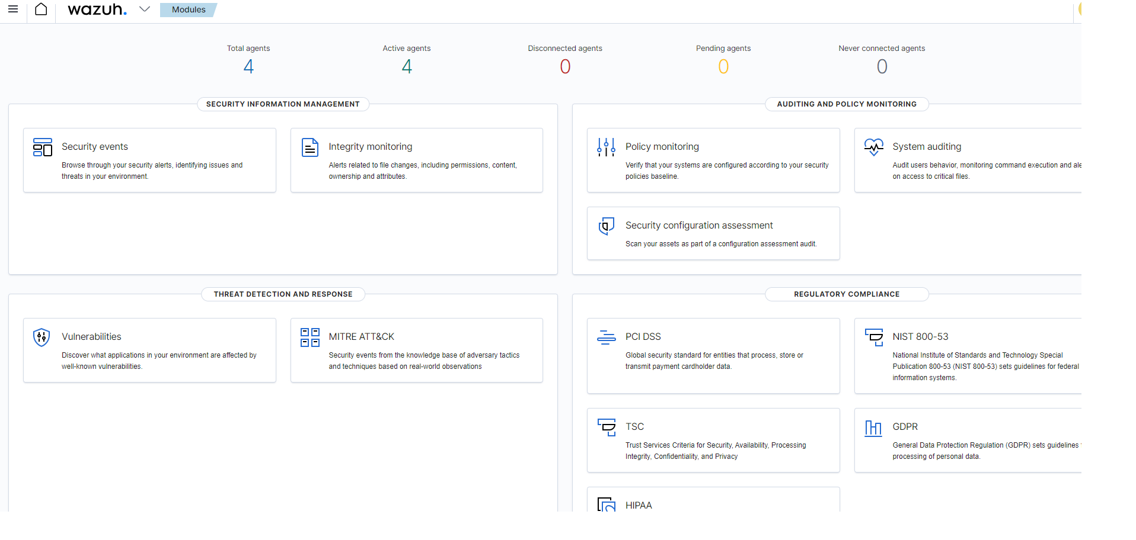

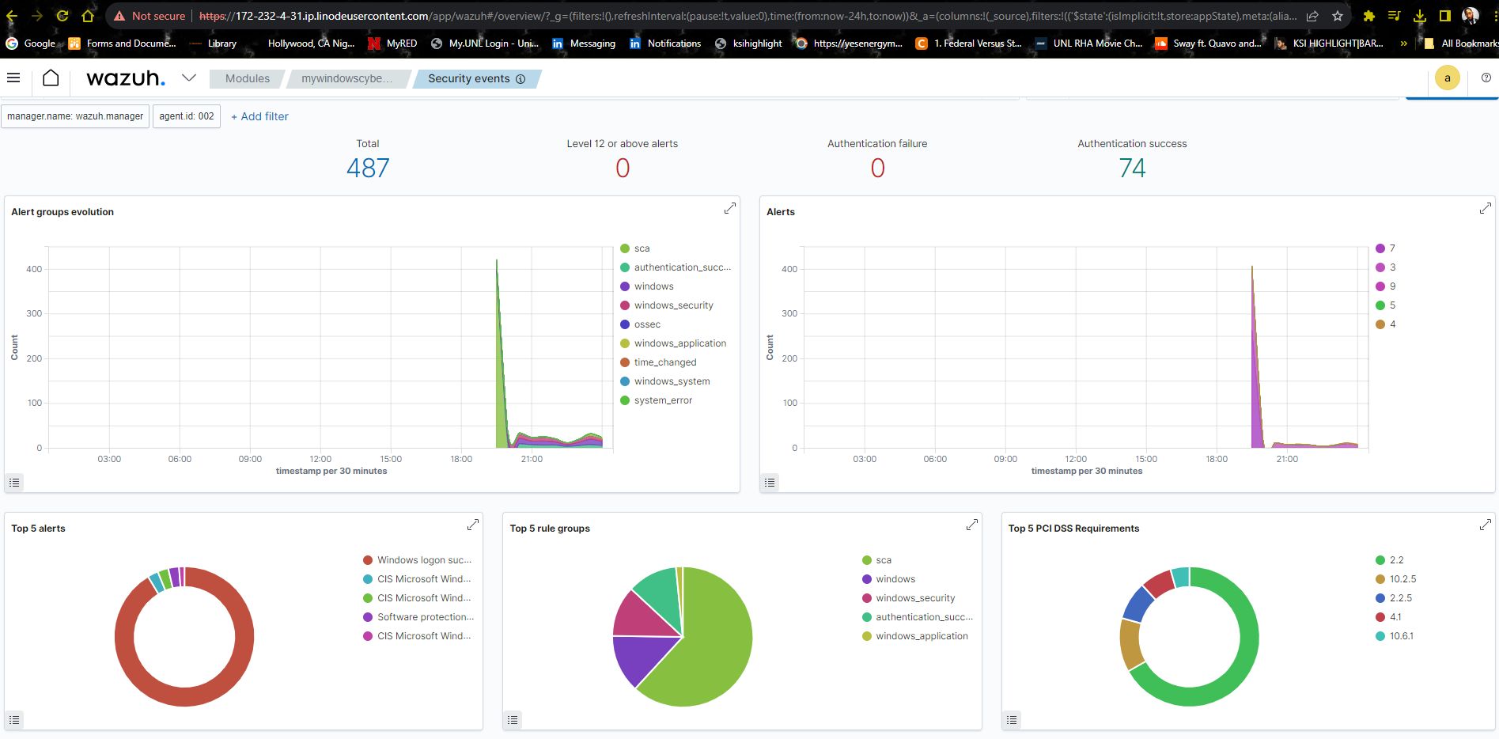

Another component is When back at this screen clicking More leads me to **Vulnerabilities**:, **Threat detection & response**

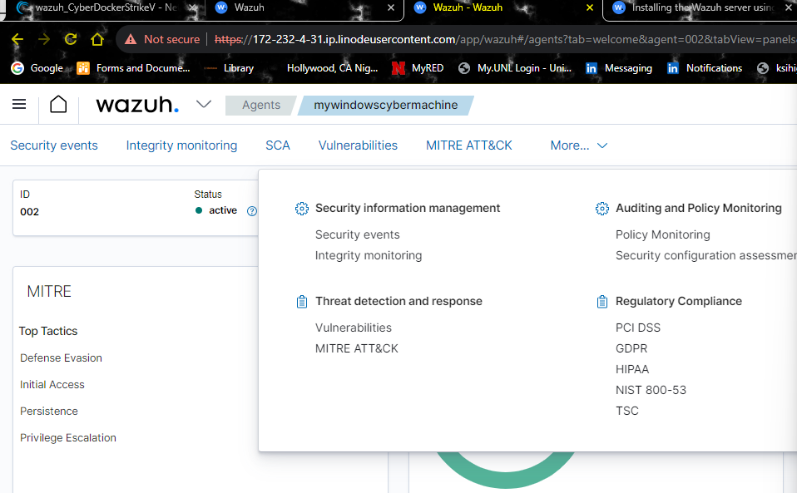

The fist step I will be presenting is file monitoring through windows. For this to be done I need to go back to the home Icon

Side note: You can unpin the current agent to show all:

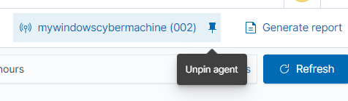

By clicking the Integrity Monitoring tab for 1st time users like myself it will be blank until you get some work done.

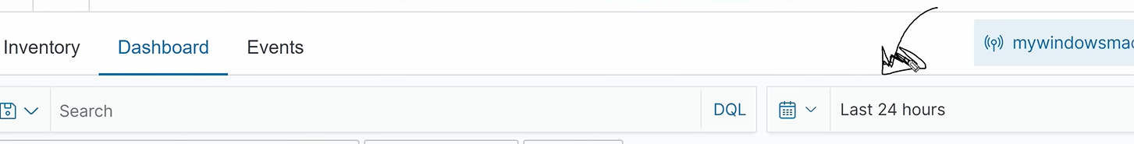

Clicking the **Inventory** has already scanned and inventoried all default files to look for in the directory and my registry keys. Right now everything is set to scan every 12hrs however if it notices a change, It’ll let me know as an alert.

Also in Files I can perform **a real-time notification and rule set.**

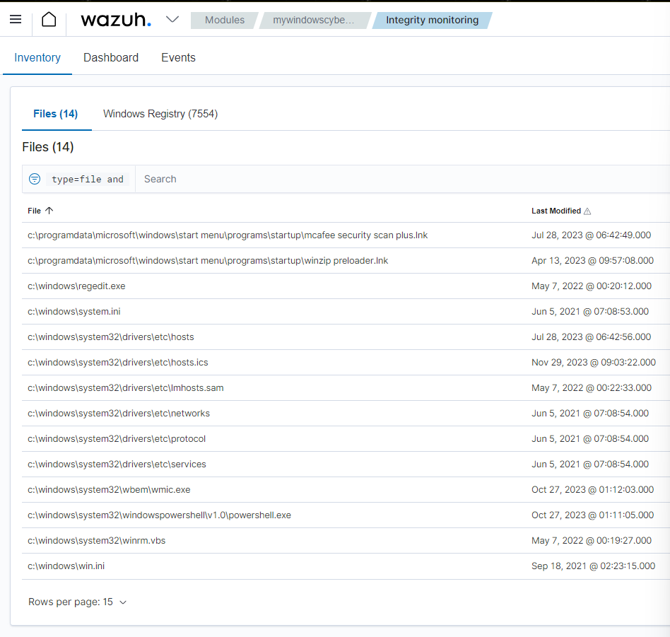

First step open This PC > Program Files (x86) > ossec-agent:

That is my configuration file for my agent.

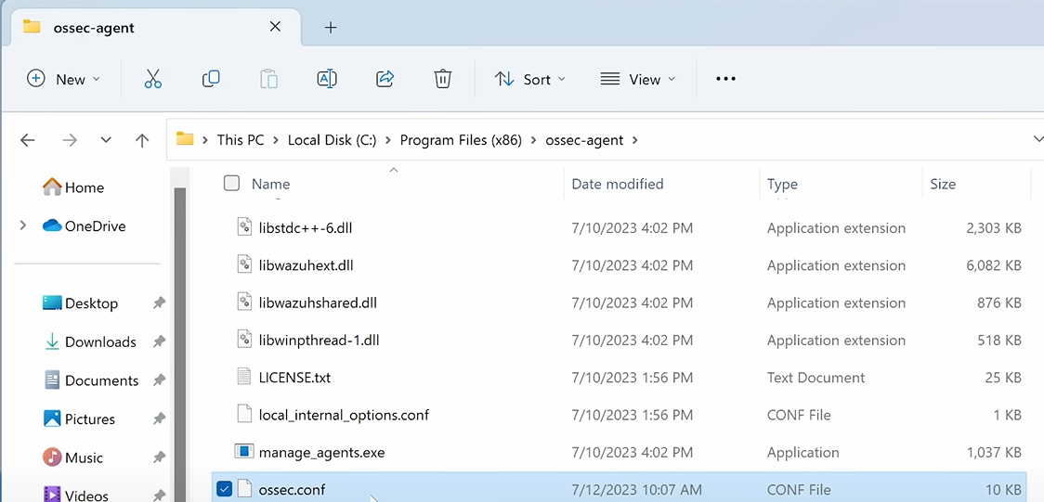

Open with Note pad

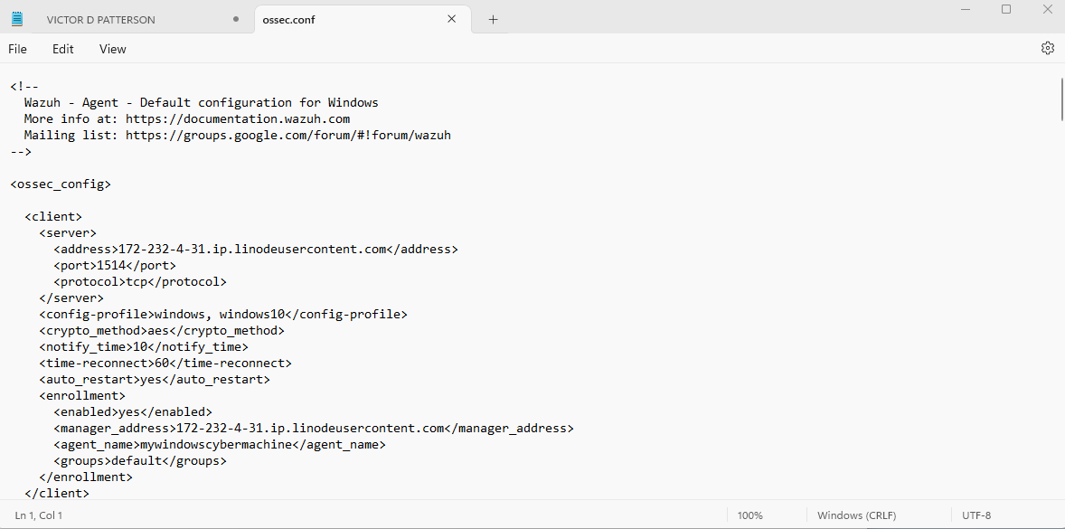

Next use the ctl: search tool in order to locate syscheck

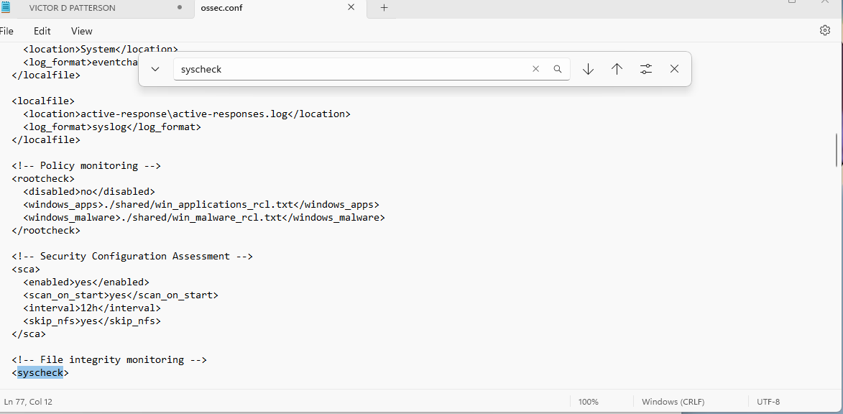

Choose a space Note: Preferably follow my path if you choose to try this.

Type in the space below <directories realtime= "yes" report_changes="yes" check_all="yes">C:\Users\vpatt\Desktop</directories>

Note: you have to use your user name from your PC and I also need to save after completing this task.

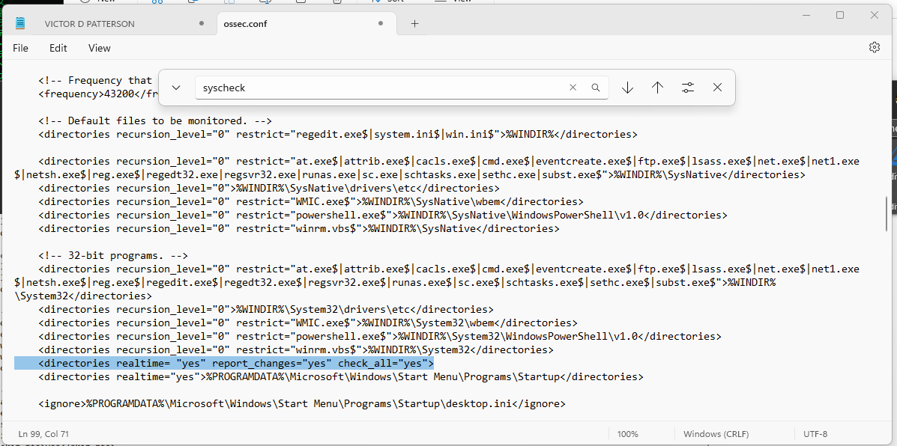

Next open PowerShell and ran as admin type restart-service -name Wazuh and enter that will be done quickly.

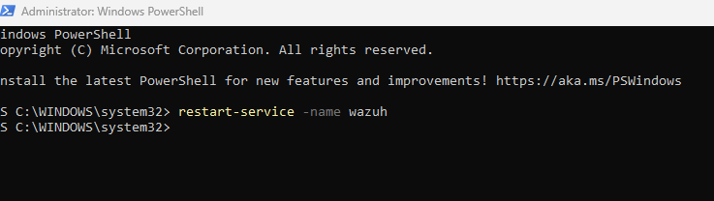

Next Open Wazuh **Dashboard** > **Integrity Monitoring** Events

